**Screenshots of the Bronze Level Table, Silver**

**Level Table, and 3 Gold Tables**

1. **This is the Bronze Table that is created**

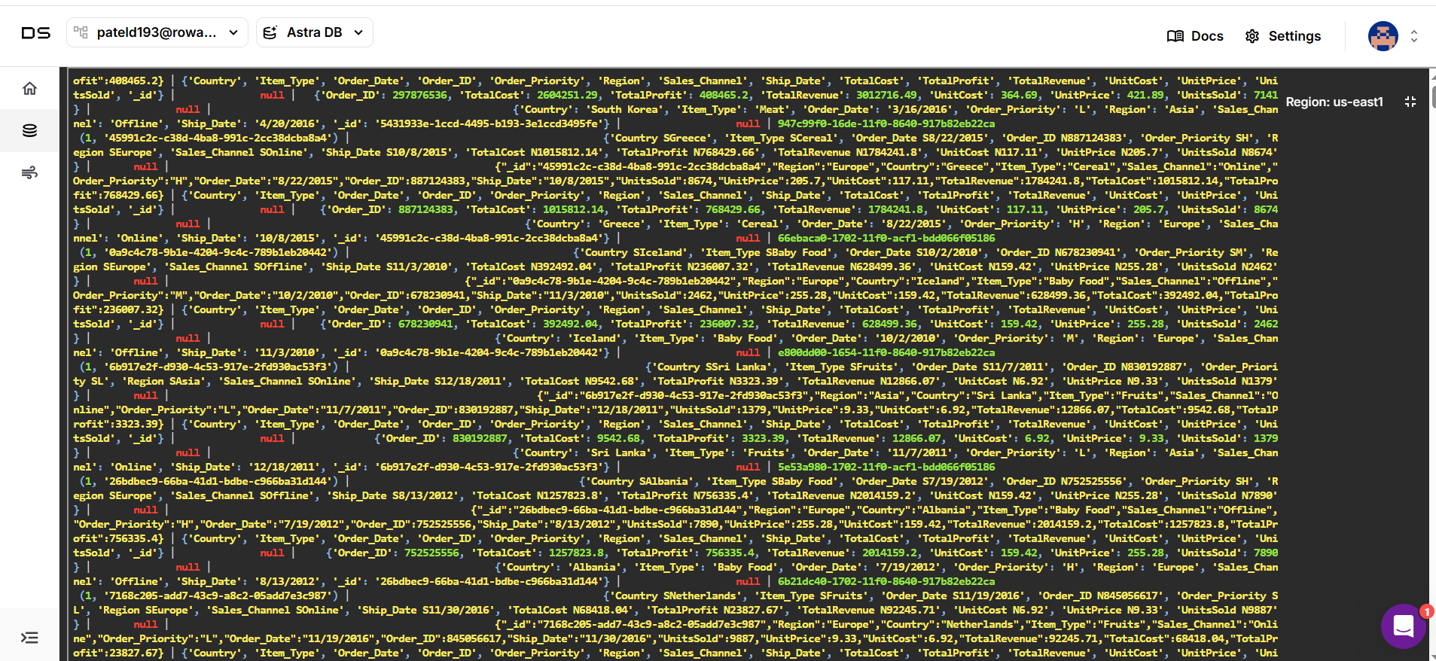

1. **This is the Silver table that is created**

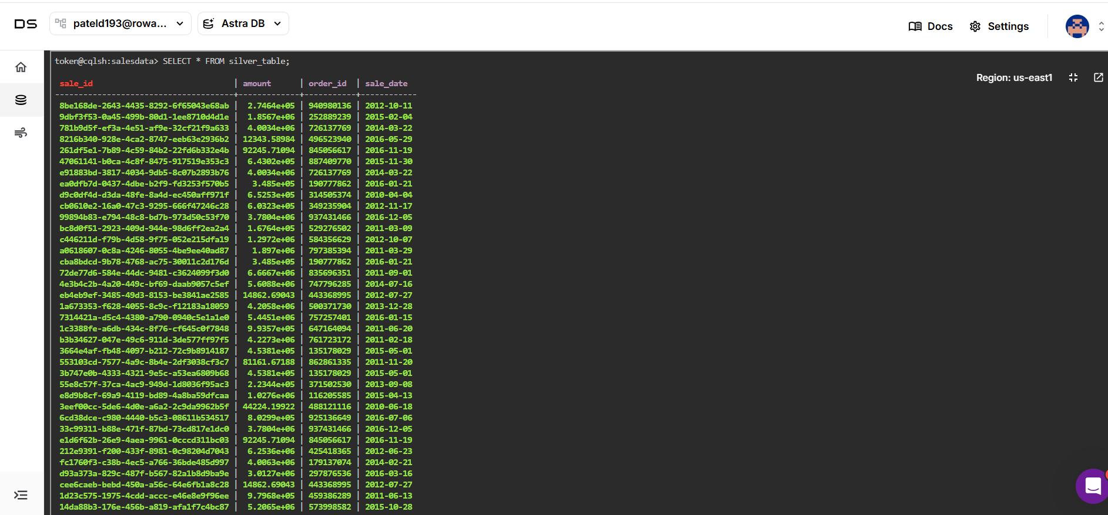

1. **This is a Gold Table1 that is created**

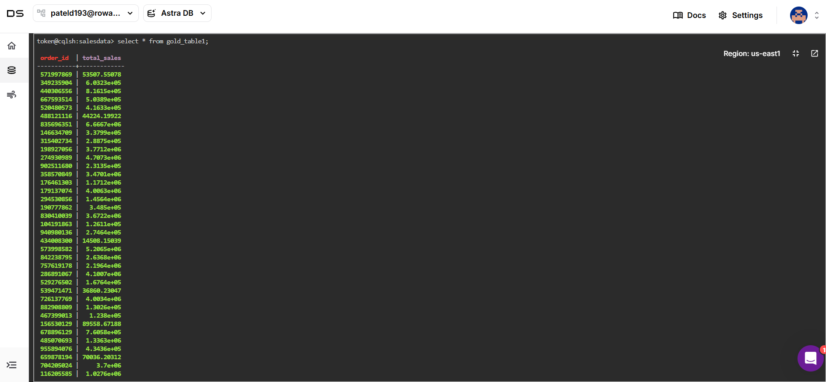

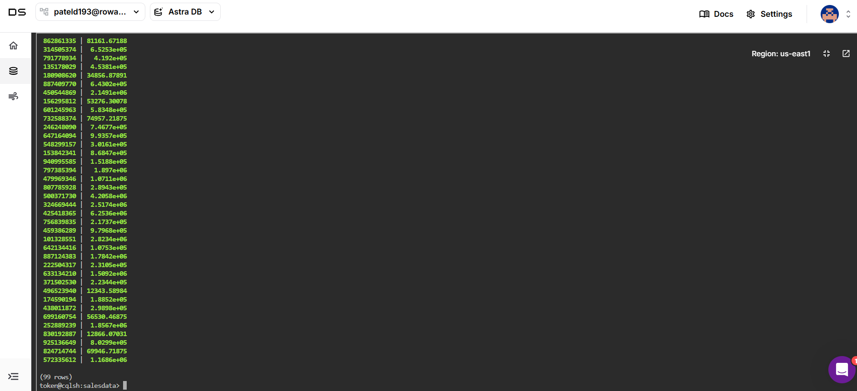

1. 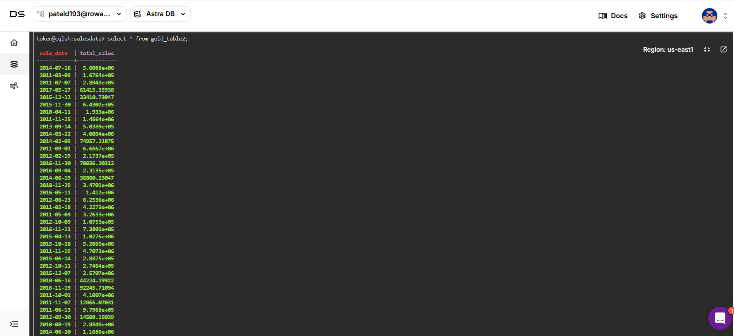**This is the Gold Table 2 that is created**

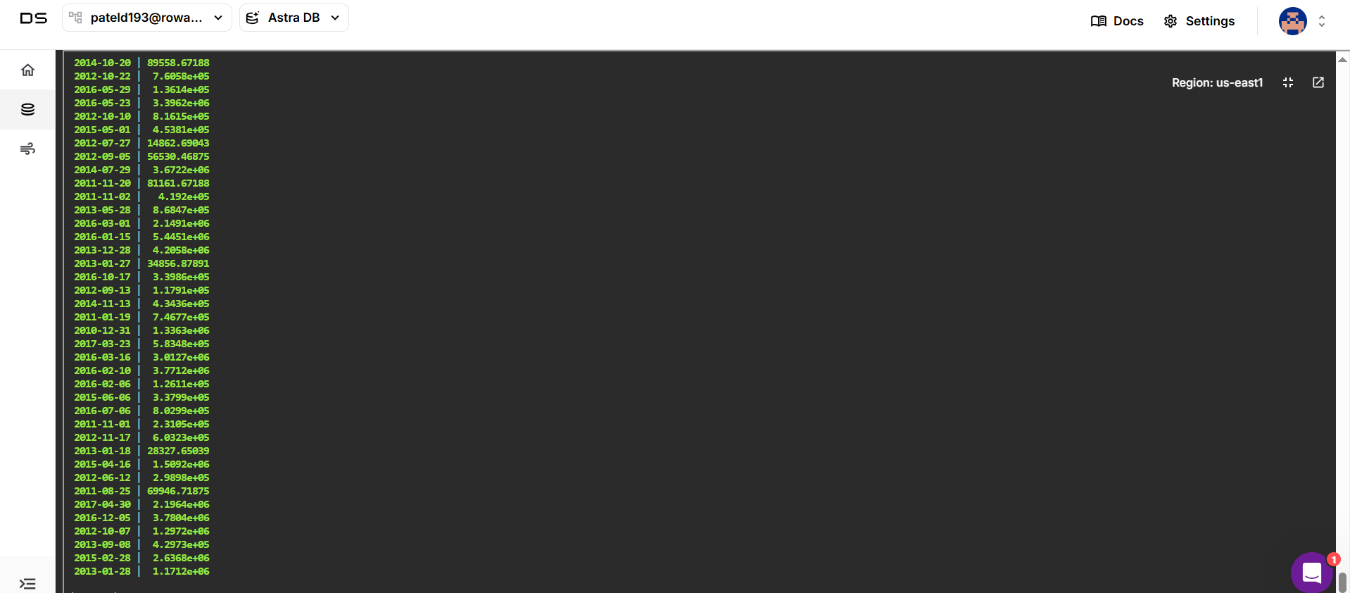

1. **This is the Gold Table 3 that is created**

